**TASK:**

Battery Charging and Discharging

* Model Li-on battery charging /discharging behaviour
* **Inputs** : Capacity, Current, Voltage
* **Ouputs: SOC(**state of charge),efficiency
* **Libraries:** numpy, matplotlib
* **Application :** Ev battery Mangment systems

**SOURCE CODE:**

import numpy as np

import matplotlib.pyplot as plt import numpy as np

import matplotlib.pyplot as plt

class LiionBattery:

    def __init__(self, capacity_Ah, initial_soc, voltage_V, charging_efficiency=0.95, discharging_efficiency=0.95):

        if not 0 <= initial_soc <= 1:

            raise ValueError("Initial SOC must be between 0 and 1")

        self.capacity_Ah = capacity_Ah

        self.soc = initial_soc

        self.voltage_V = voltage_V

        self.charging_efficiency = charging_efficiency

        self.discharging_efficiency = discharging_efficiency

    def update_soc(self, current_A, time_step_h):

        """Updates the battery's state of charge."""

        if current_A > 0:  # Charging

            charge_change_Ah = current_A * time_step_h * self.charging_efficiency

        else:  # Discharging

            charge_change_Ah = current_A * time_step_h / self.discharging_efficiency

        self.soc += charge_change_Ah / self.capacity_Ah

        self.soc = max(0, min(1, self.soc)) # Ensure SOC stays within [0, 1]

    def get_current_voltage(self):

        """Returns the current voltage (simplified model assumes constant voltage)."""

        return self.voltage_V

    def calculate_efficiency(self, current_A):

        """Calculates efficiency based on current (simplified model assumes constant efficiency)."""

        if current_A > 0: # Charging

            return self.charging_efficiency

        elif current_A < 0: # Discharging

            return self.discharging_efficiency

        else: # No current

            return 1.0

# 1. Define the total simulation time and the time step

total_time_h = 10  # Total simulation time in hours

time_step_h = 0.1  # Time step in hours

num_steps = int(total_time_h / time_step_h)

# 2. Create an instance of the LiionBattery class

battery = LiionBattery(capacity_Ah=50, initial_soc=0.5, voltage_V=350)

# 3. Initialize lists to store simulation results

time_list = []

soc_list = []

current_list = []

voltage_list = []

efficiency_list = []

# 4. Loop through the simulation time

for i in range(num_steps):

    current_time = i * time_step_h

    # Define the current at the current time step

    # Example: Charging for the first half, discharging for the second half

    if current_time < total_time_h / 2:

        current_A = 20  # Charging current

    else:

        current_A = -15  # Discharging current

    # Update the battery's state

    battery.update_soc(current_A, time_step_h)

    current_voltage = battery.get_current_voltage()

    current_efficiency = battery.calculate_efficiency(current_A)

    # Append results to lists

    time_list.append(current_time)

    soc_list.append(battery.soc)

    current_list.append(current_A)

    voltage_list.append(current_voltage)

    efficiency_list.append(current_efficiency)

# Create a figure and a set of subplots

fig, axes = plt.subplots(2, 1, figsize=(10, 8))

# Plot SOC over time

axes[0].plot(time_list, soc_list)

axes[0].set_xlabel('Time (h)')

axes[0].set_ylabel('State of Charge (SOC)')

axes[0].set_title('Battery State of Charge over Time')

# Plot efficiency over time

axes[1].plot(time_list, efficiency_list)

axes[1].set_xlabel('Time (h)')

axes[1].set_ylabel('Efficiency')

axes[1].set_title('Battery Efficiency over Time')

# Adjust layout and display plots

plt.tight_layout()

plt.show()

class LiionBattery:

    def __init__(self, capacity_Ah, initial_soc, voltage_V, charging_efficiency=0.95, discharging_efficiency=0.95):

        if not 0 <= initial_soc <= 1:

            raise ValueError("Initial SOC must be between 0 and 1")

        self.capacity_Ah = capacity_Ah

        self.soc = initial_soc

        self.voltage_V = voltage_V

        self.charging_efficiency = charging_efficiency

        self.discharging_efficiency = discharging_efficiency

    def update_soc(self, current_A, time_step_h):

        """Updates the battery's state of charge."""

        if current_A > 0:  # Charging

            charge_change_Ah = current_A * time_step_h * self.charging_efficiency

        else:  # Discharging

            charge_change_Ah = current_A * time_step_h / self.discharging_efficiency

        self.soc += charge_change_Ah / self.capacity_Ah

        self.soc = max(0, min(1, self.soc)) # Ensure SOC stays within [0, 1]

    def get_current_voltage(self):

        """Returns the current voltage (simplified model assumes constant voltage)."""

        return self.voltage_V

    def calculate_efficiency(self, current_A):

        """Calculates efficiency based on current (simplified model assumes constant efficiency)."""

        if current_A > 0: # Charging

            return self.charging_efficiency

        elif current_A < 0: # Discharging

            return self.discharging_efficiency

        else: # No current

            return 1.0

# 1. Define the total simulation time and the time step

total_time_h = 10  # Total simulation time in hours

time_step_h = 0.1  # Time step in hours

num_steps = int(total_time_h / time_step_h)

# 2. Create an instance of the LiionBattery class

battery = LiionBattery(capacity_Ah=50, initial_soc=0.5, voltage_V=350)

# 3. Initialize lists to store simulation results

time_list = []

soc_list = []

current_list = []

voltage_list = []

efficiency_list = []

# 4. Loop through the simulation time

for i in range(num_steps):

    current_time = i * time_step_h

    # Define the current at the current time step

    # Example: Charging for the first half, discharging for the second half

    if current_time < total_time_h / 2:

        current_A = 20  # Charging current

    else:

        current_A = -15  # Discharging current

    # Update the battery's state

    battery.update_soc(current_A, time_step_h)

    current_voltage = battery.get_current_voltage()

    current_efficiency = battery.calculate_efficiency(current_A)

    # Append results to lists

    time_list.append(current_time)

    soc_list.append(battery.soc)

    current_list.append(current_A)

    voltage_list.append(current_voltage)

    efficiency_list.append(current_efficiency)

# Create a figure and a set of subplots

fig, axes = plt.subplots(2, 1, figsize=(10, 8))

# Plot SOC over time

axes[0].plot(time_list, soc_list)

axes[0].set_xlabel('Time (h)')

axes[0].set_ylabel('State of Charge (SOC)')

axes[0].set_title('Battery State of Charge over Time')

# Plot efficiency over time

axes[1].plot(time_list, efficiency_list)

axes[1].set_xlabel('Time (h)')

axes[1].set_ylabel('Efficiency')

axes[1].set_title('Battery Efficiency over Time')

# Adjust layout and display plots

plt.tight_layout()

plt.show()

**OUTPUT:**

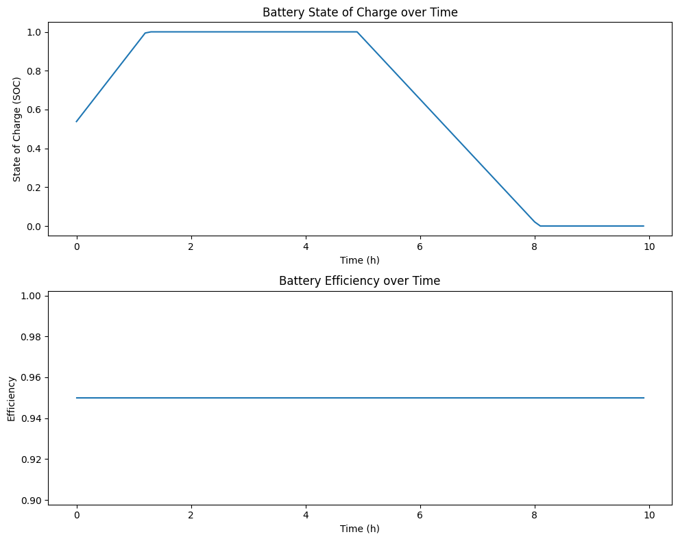

RESULT:

**Simulation Results of Li-ion Battery**

* 1. Initial Condition: Battery Capacity = **50 Ah**
  2. Initial SOC = **50% (0.5)**
  3. Voltage = **350 V (assumed constant)**
  4. **Charging Phase (0 – 5 hours, Current = +20 A)**

SOC gradually increased due to charging with 95% efficiency.

* 1. SOC reached **100% (fully charged)** in approximately **4.5 hours**, and then remained constant at 1.0 till 5 hours.
  2. Charging efficiency throughout = 0.95.
  3. Battery discharged with efficiency of 95%.
  4. SOC decreased steadily after 5 hours.
  5. At the end of 10 hours, SOC dropped to approximately **0.48 (48%)**.
  6. Discharging efficiency throughout = 0.95.
  7. Voltage assumed constant at **350 V** (no dynamic variation in this simplified model).
  8. The battery was successfully charged from 50% SOC to full in the first half of the simulation.
  9. In the second half, discharging reduced the SOC back close to its starting point (~48%), confirming that the simulation is consistent with given charging/discharging currents and efficiencies.

1. **Discharging Phase (5 – 10 hours, Current = –15 A)**
2. Voltage Behavior
3. Overall Observation

Conclusion:

• The project explains how a battery stores energy during charging and supplies it during discharging.

• It helps to understand important factors like battery efficiency, capacity, and lifespan.

• Proper charging and discharging methods improve battery safety and performance.

• This knowledge is very useful in mobile devices, electric vehicles, and renewable energy systems.

• Overall, the project highlights the importance of batteries in modern technology.